

**Internet Technologies project:**

**blogging platform website**

Supervised by:

* Dr. Marwa Refaey
* Dr. Aya Saber
* Dr. Gerges Morad
* Dr. Amal Mohamed
* Dr. AbdelRahman Essam
* Dr. Rana Saad
* Dr. Haydi Magdy

Team Members:

* Khalid karam Mohamed Soliman id:97135 G (3)
* Khaled Amr Ahmed Badr id:98773 G (3)
* Khaled Akram khairy Ahmed id:99012 G (3)
* Youssef Ahmed Mahmoud Hassan id:97666 G (8)
* Abdelrahman Sayed Mostafa Elsayed id:098934 G (4)

**Contents**

Core Functionalities of the Website: 3

Frist: benefits or value of the blogging platform website 3

Second: Who is going to the blogging platform website 4

Wireframes: 5

3-User Flow: 9

4-Usecase: 10

5-Sequence diagram 11

Activity Diagram 12

Sitemap: 13

13

pert chart: 14

ER diagram: 15

Story mapping: 16

deployment diagram 17

Test case: 18

# Core Functionalities of the Website:

## Frist: benefits or value of the blogging platform website

A blogging platform website offers several benefits and value to its users

* **Ease of Use**: Blogging platforms typically provide user-friendly interfaces and intuitive tools that make it easy for bloggers to create and manage their content. They eliminate the need for technical skills or coding knowledge, allowing individuals to focus on their writing and creativity rather than website management.
* **Content Creation and Publishing**: The platform streamlines the process of creating and publishing blog content. It offers text editors with formatting options, media embedding capabilities, and tools for organizing and categorizing posts.
* **Customization and Personalization**: Blogging platforms provide a range of customizable themes, templates, and design options. Bloggers can personalize the appearance of their blogs to reflect their unique style and branding.
* **Community and Networking**: Blogging platforms often foster a sense of community among bloggers and readers. They provide features like comment sections, social sharing, and follow/subscriber options, enabling interaction and engagement.
* **Monetization Opportunities:** Some blogging platforms provide monetization options, such as displaying ads, incorporating affiliate marketing, or offering paid content or membership subscriptions.

## Second: Who is going to the blogging platform website

* **Bloggers:** The primary beneficiaries are bloggers themselves. They can utilize the platform to create, manage, and publish their blog content. The platform offers them a user-friendly interface, tools for customization, and features like content organization, SEO optimization, and social sharing. It provides a platform for bloggers to showcase their expertise, share their thoughts and ideas, and engage with their audience.
* **Readers and Visitors:** The website benefits readers and visitors who are interested in consuming blog content. They can discover and access a wide range of blogs on different topics through the platform.
* **Content Creators:** The blogging platform website can benefit content creators beyond bloggers. It provides opportunities for guest blogging or contributing articles on specific topics.
* **Businesses and Brands:** Businesses and brands can benefit from the website by utilizing it as a content marketing tool. They can create and maintain a company blog to share valuable insights, industry trends, product updates, or thought leadership content.

# Wireframes:

**Wireframes** are visual representations or low-fidelity sketches that outline the basic structure and layout of a website, application, or user interface (UI) design. They serve as a blueprint for the design process and provide a visual guide for designers, developers, and stakeholders.

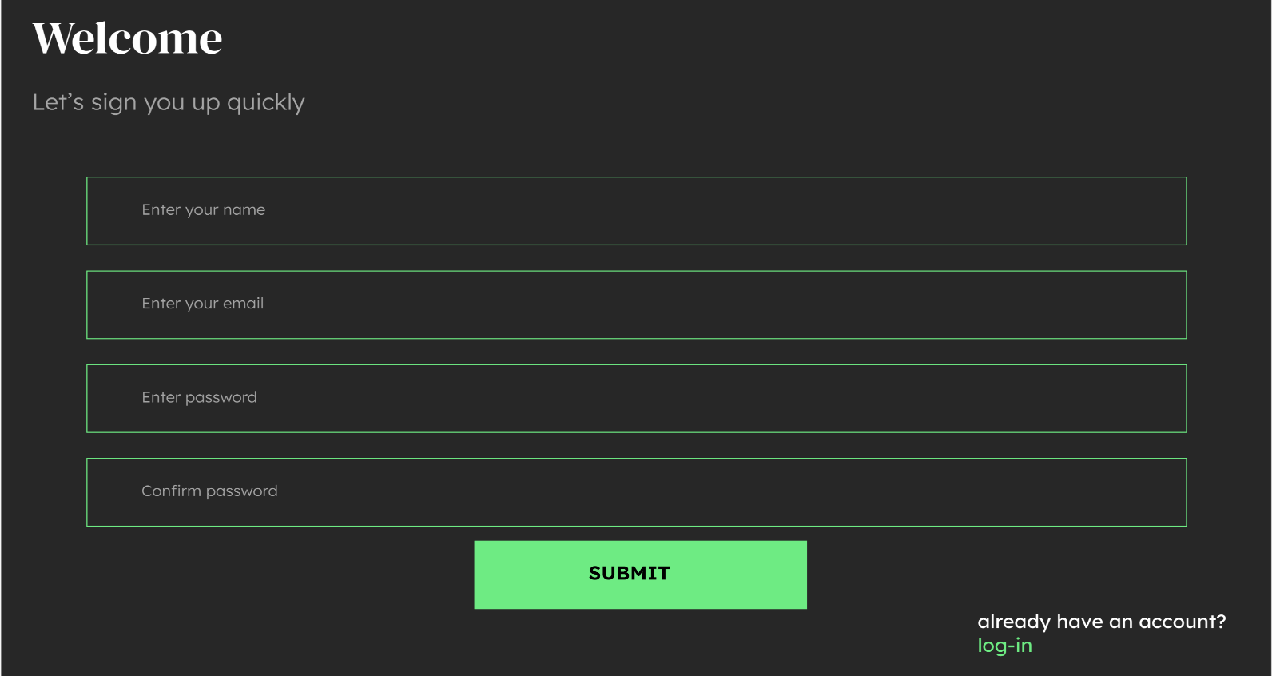

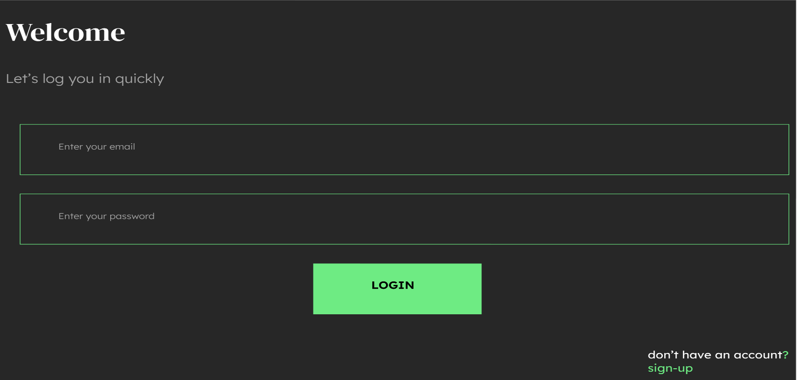

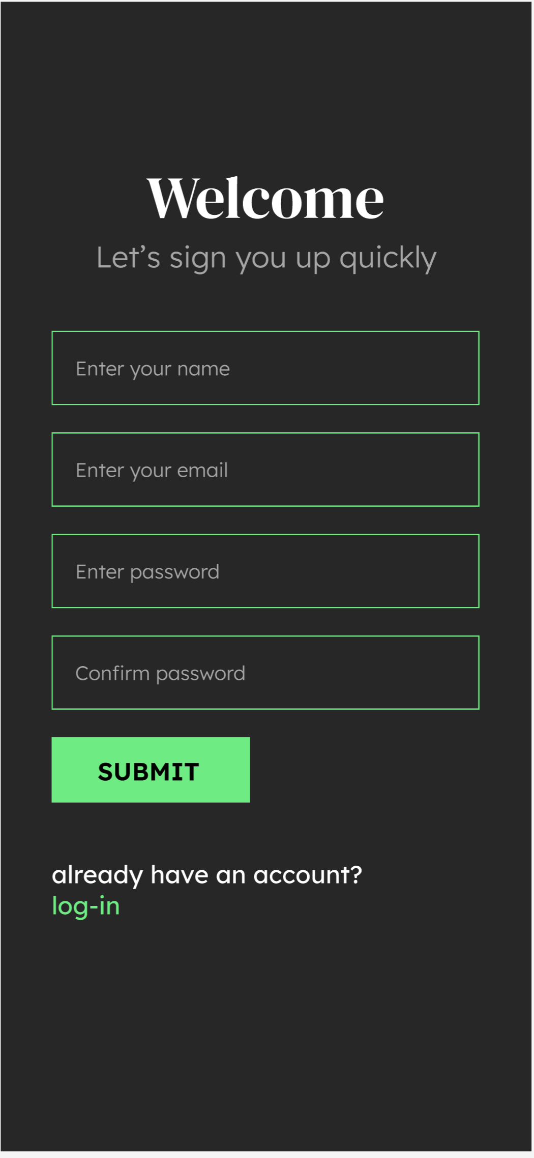

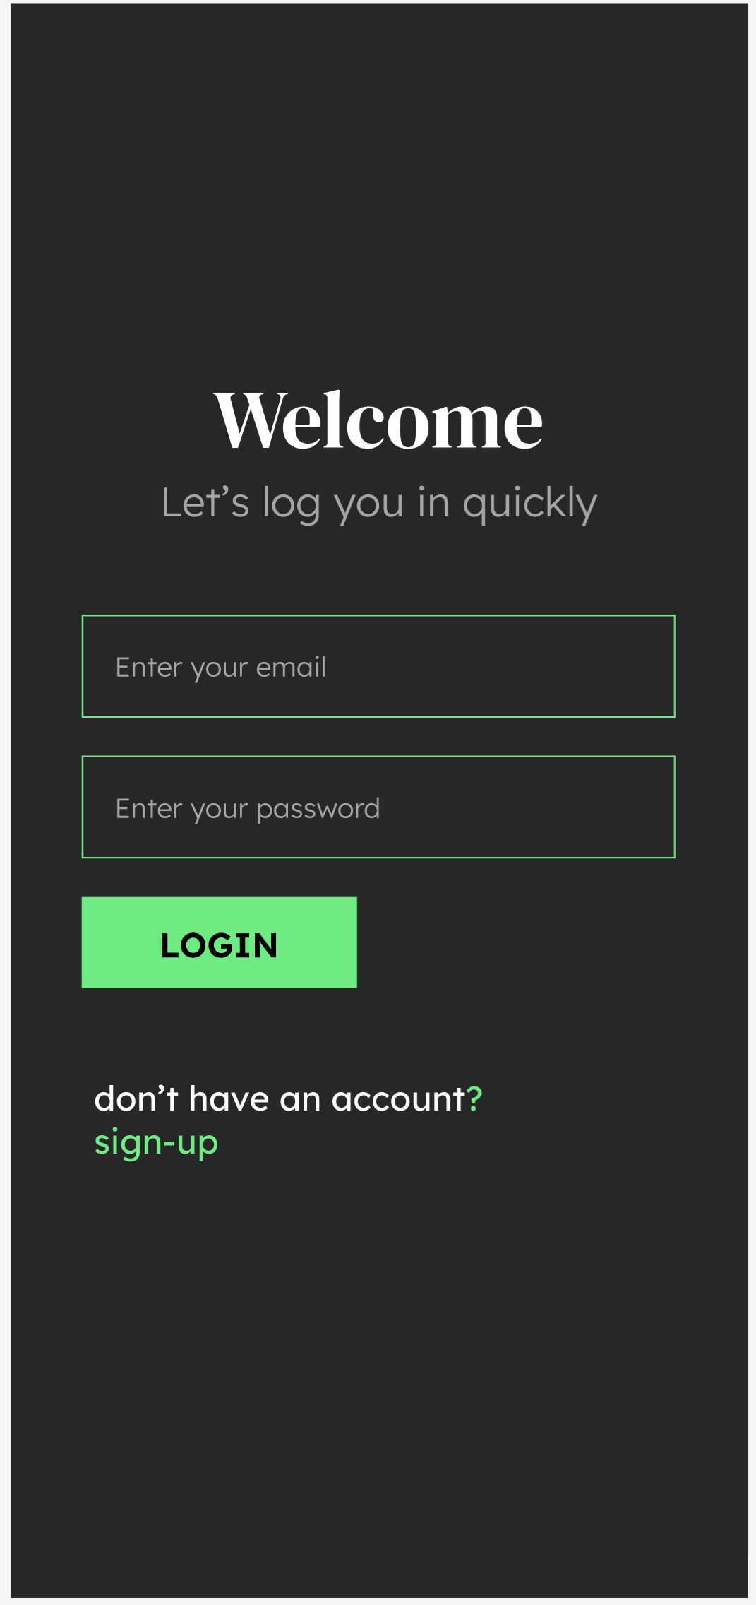

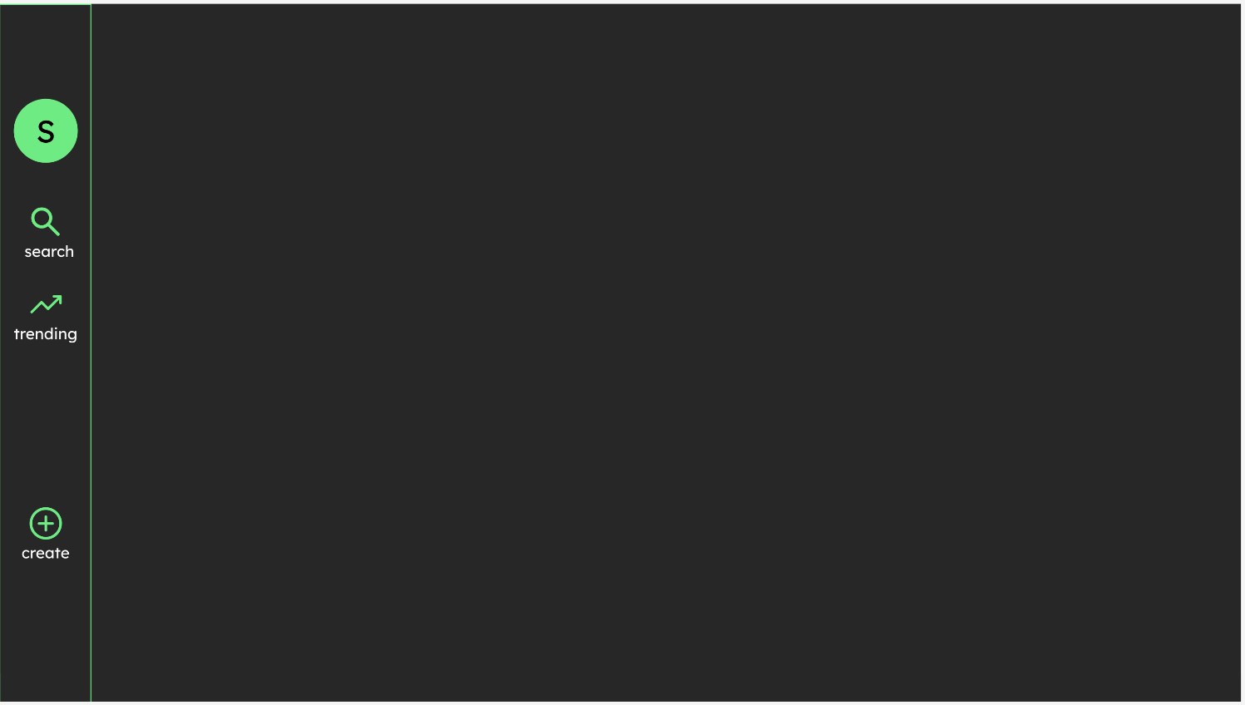

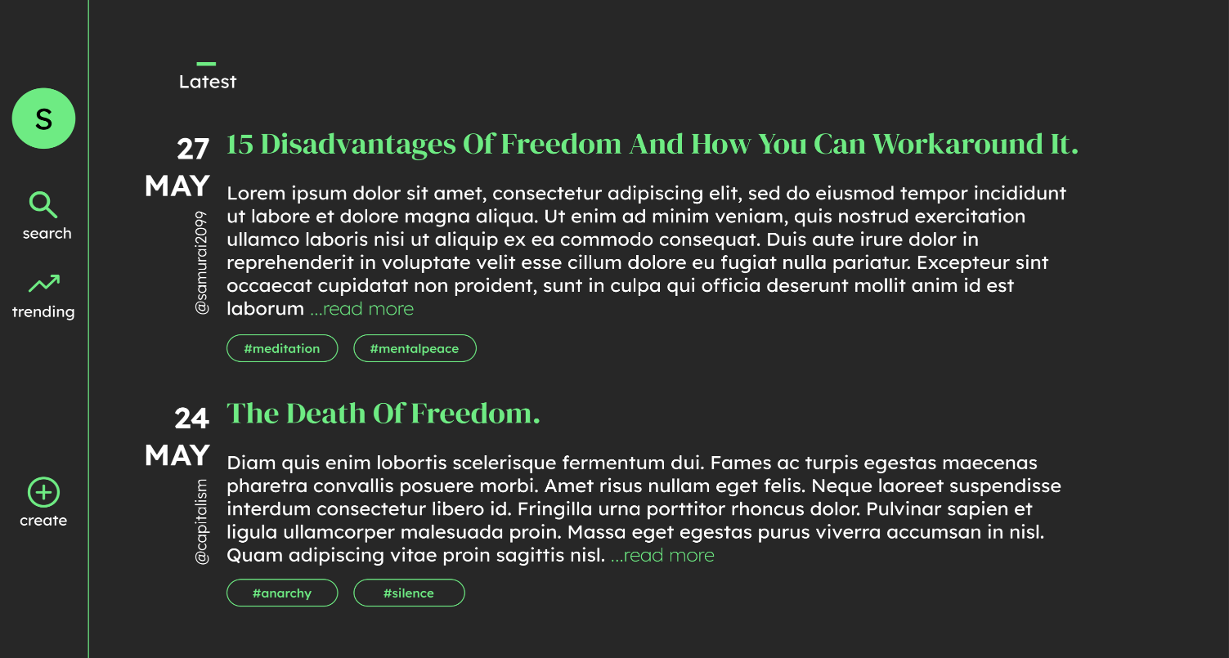

**User Flow:** Diagram is a chart or diagram showing the path a user will take in an application to complete a task. 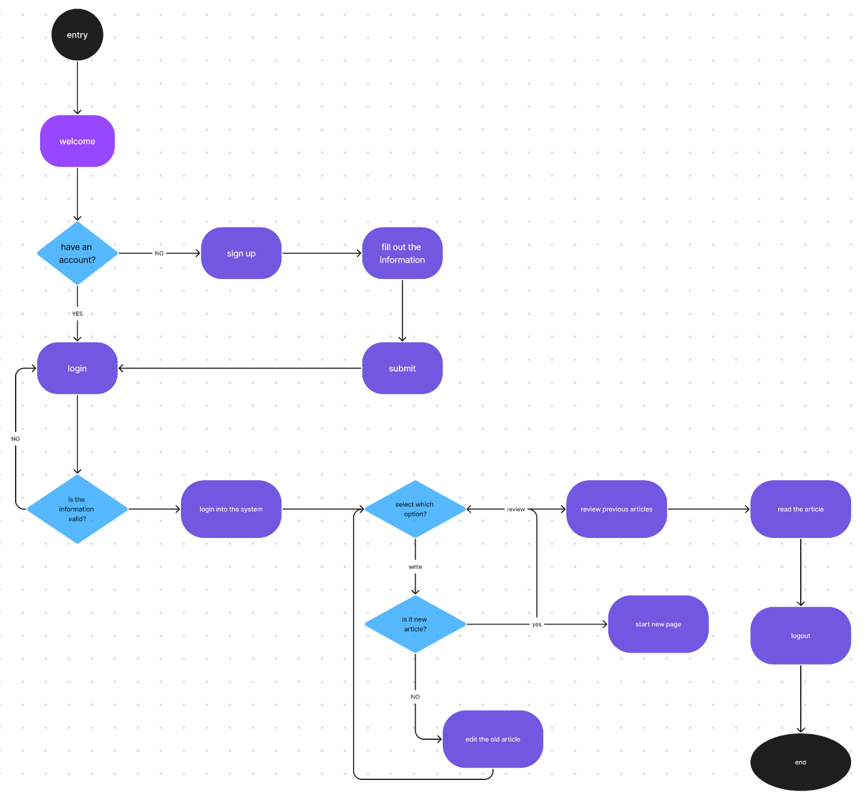

**Usecase:**it represents specific flows of events in the system are initiated by actors and describe the flow of events that these actors are involved in Anything that interact with a use case, it could be a human, external hardware (like a time) or another system

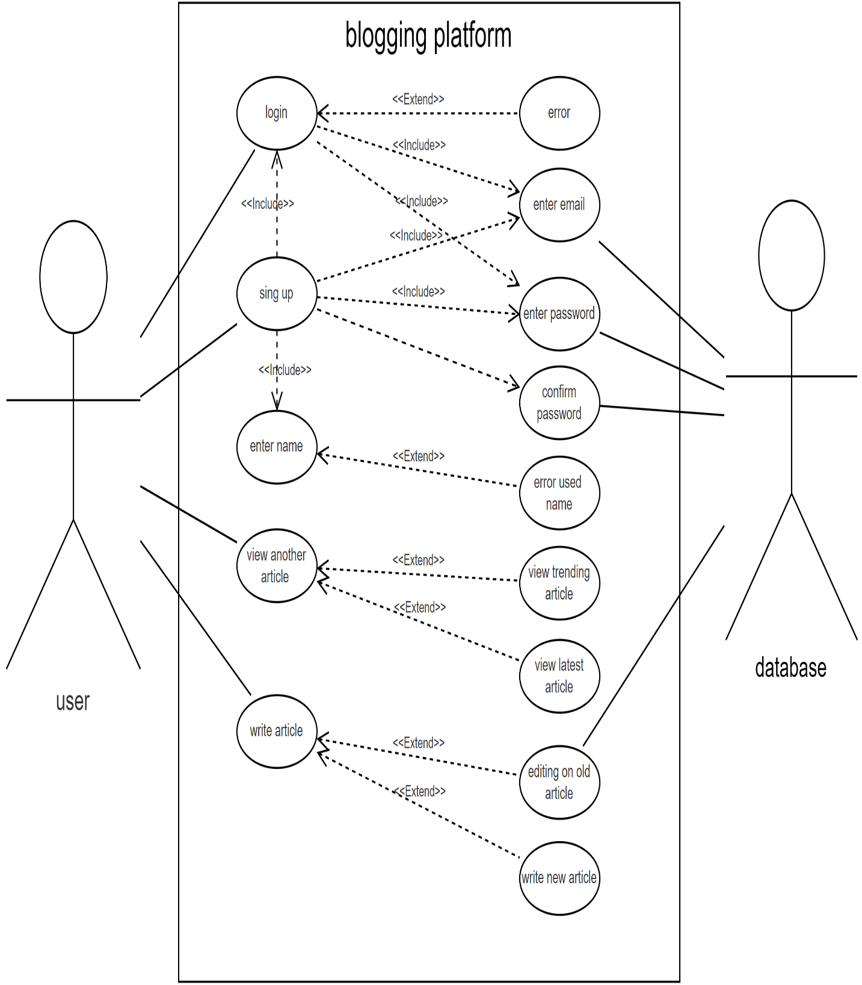

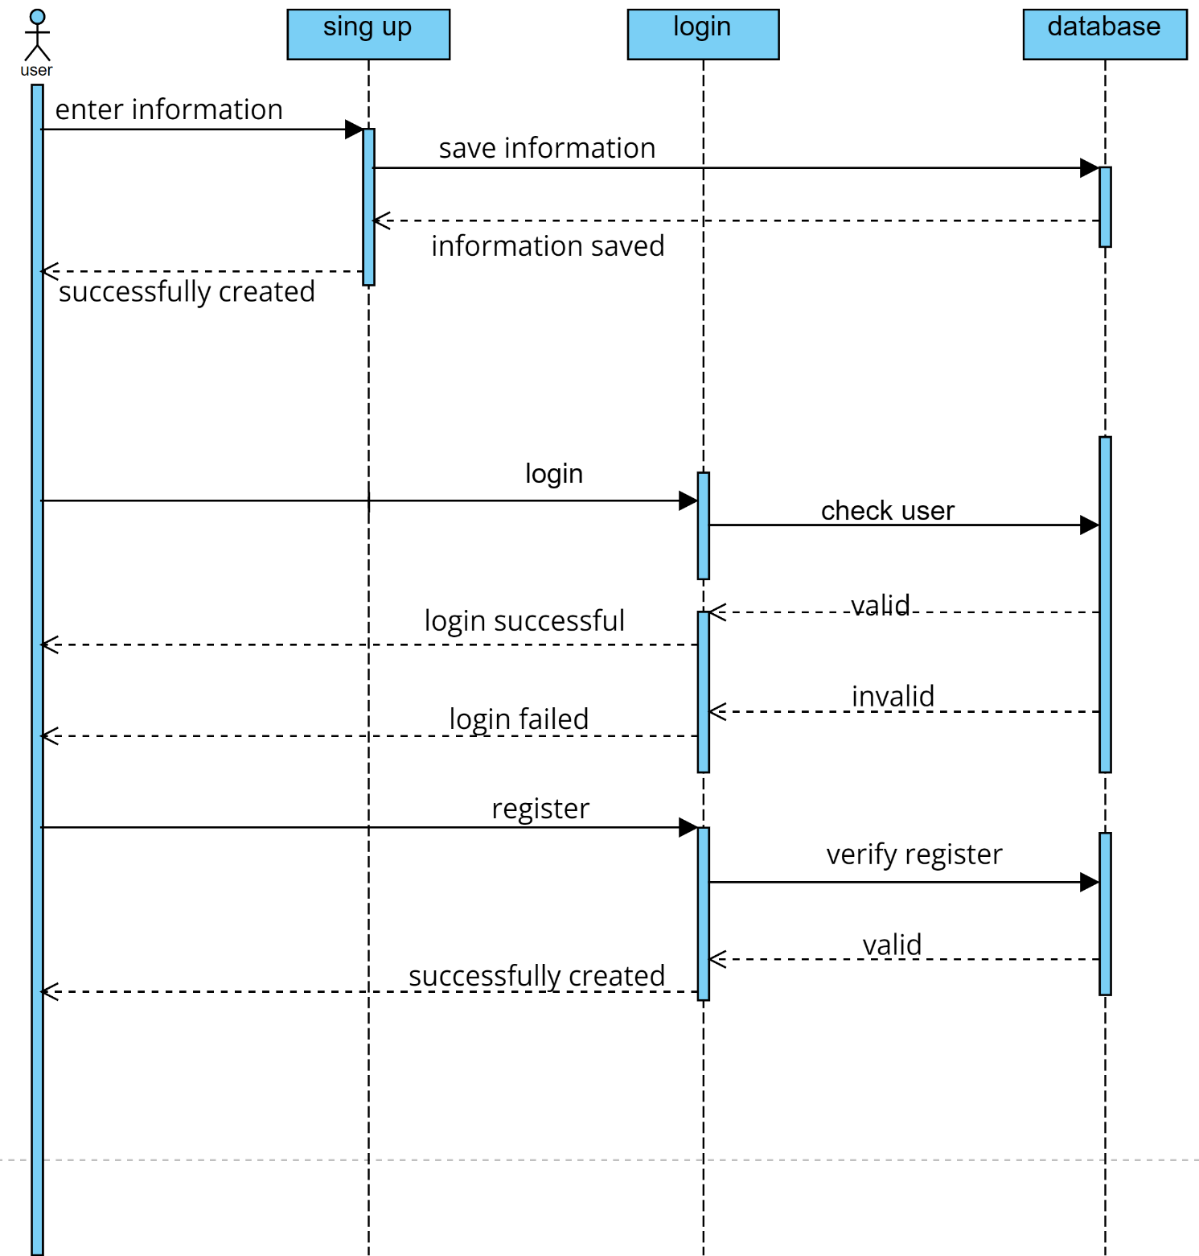

**Sequence diagram** are interaction diagrams that detail how operations are carried out. They capture the interaction between objects in the context of a collaboration

# 

**Activity Diagram**: An activity diagram shows a process as a set of activities, showing their sequences, where activities can be carried out in parallel and show which person is responsible for which activity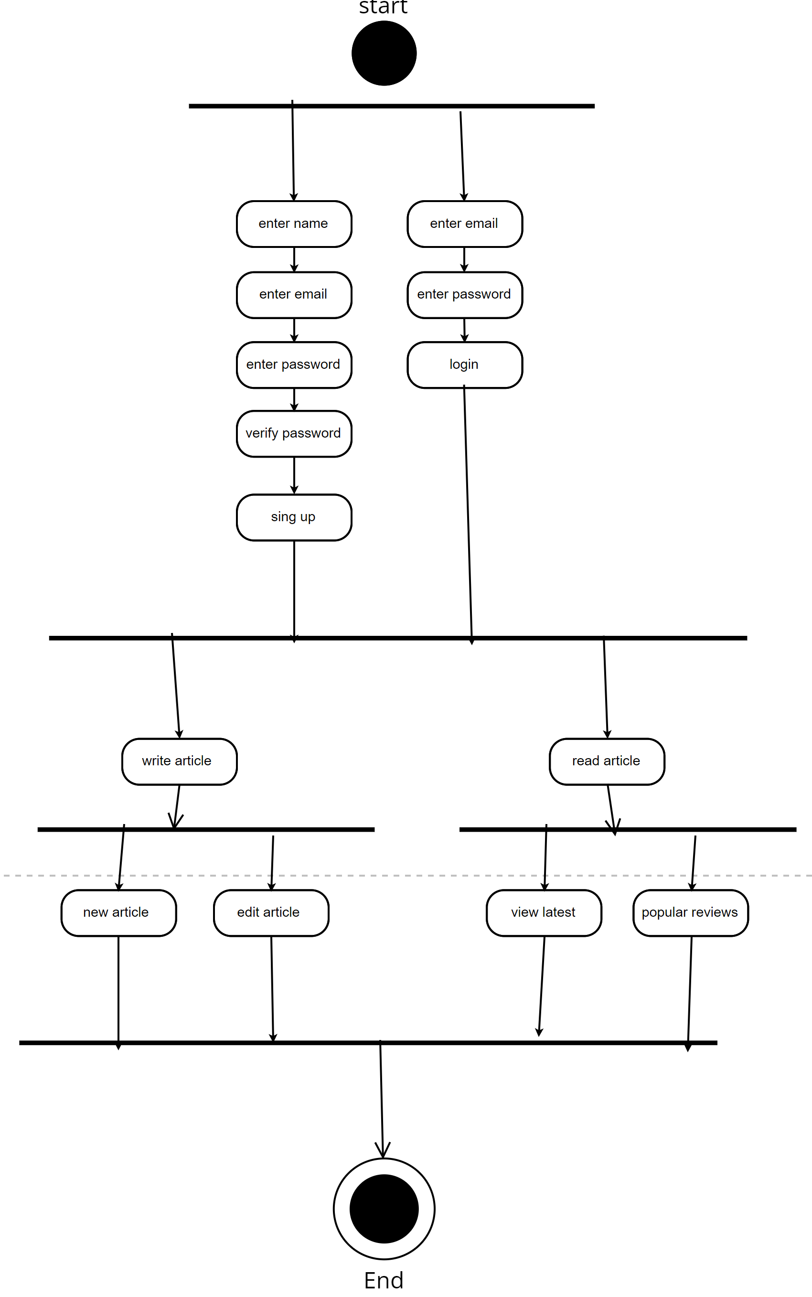

**Sitemap:** A sitemap is a file that shows the structure of a website, including its pages and content and the relationships between them. Search engines use sitemaps to crawl websites more efficiently.

# 

**pert chart:**  is a project management tool used to schedule, organize and coordinate tasks within a project. It provides a graphical representation of a project's timeline that enables project managers to break down each individual task in the project for analysis.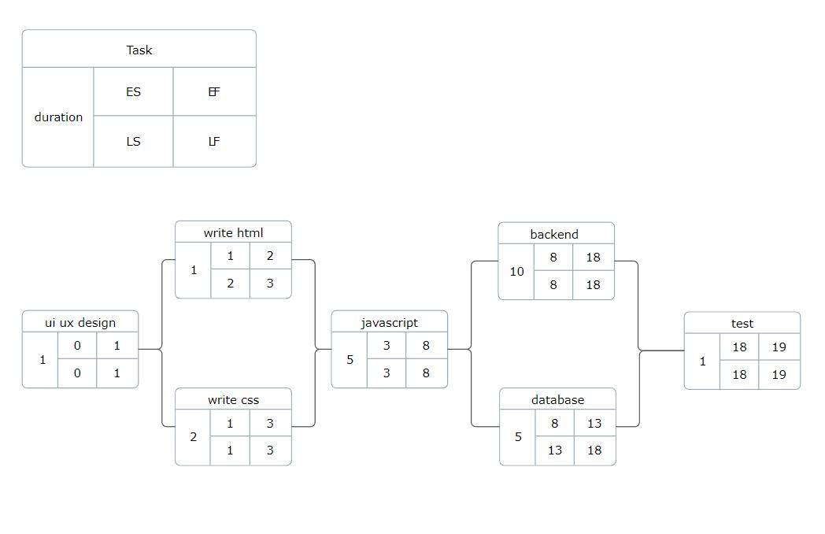

**ER diagram:**  is a visual representation used to model the structure and relationships of entities in a database 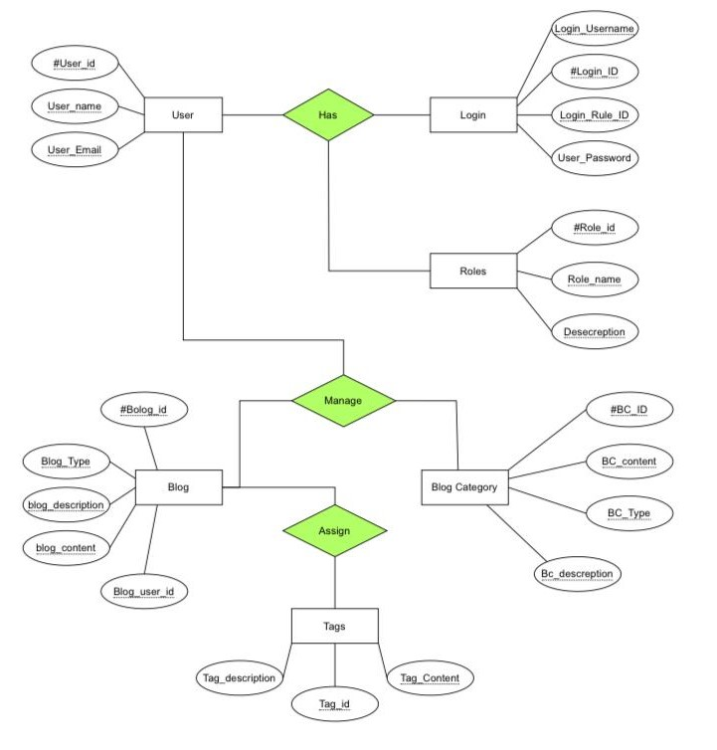

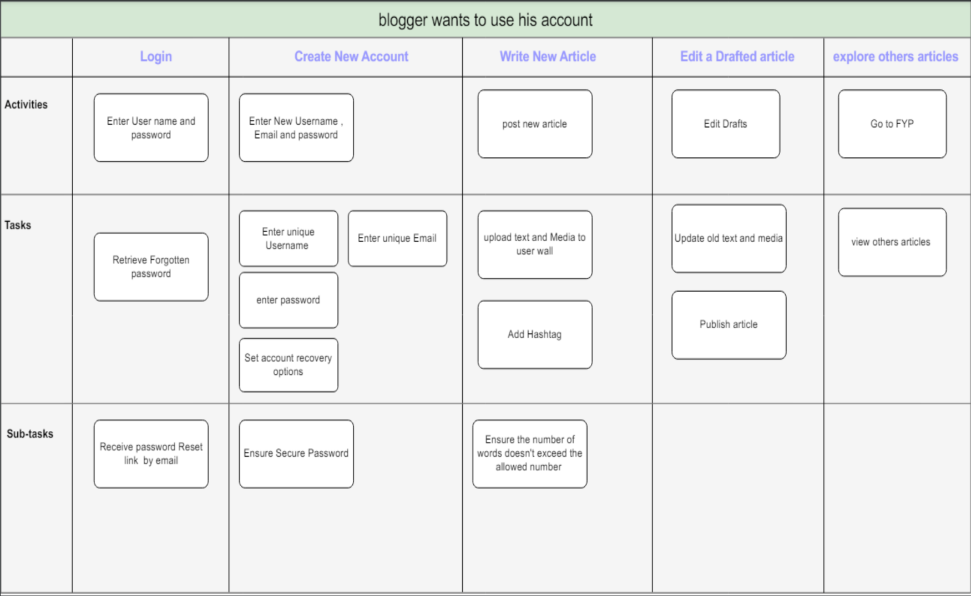**Story mapping:** is a collaborative technique used in agile software development to visually organize and prioritize user stories or product features. It helps teams gain a shared understanding of the product's functionality and create a roadmap for development.

**deployment diagram** is a type of diagram in the Unified Modeling Language (UML) that represents the physical deployment of software components and hardware nodes in a system.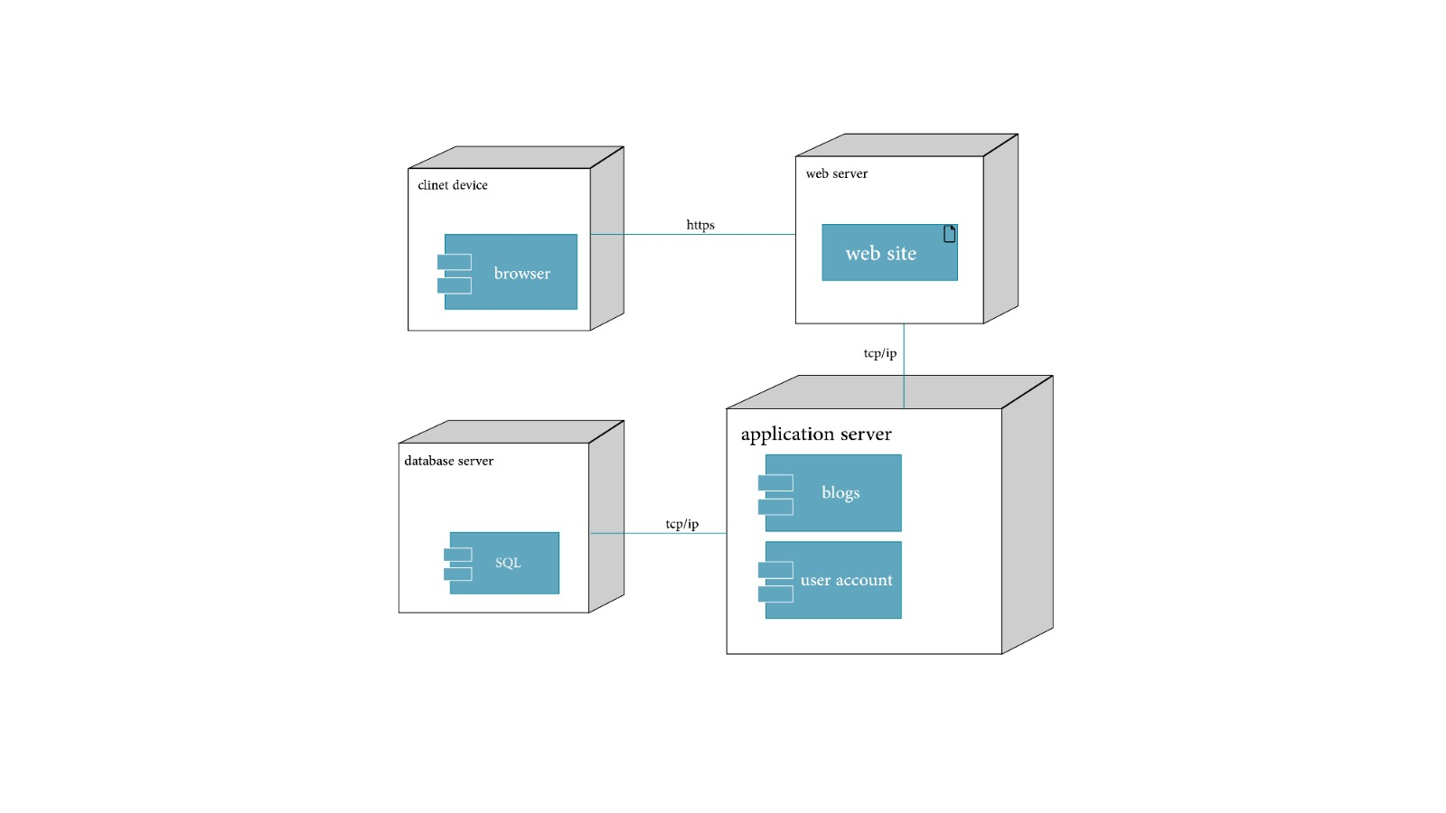

|  |  |  |  |  |  |  |
| --- | --- | --- | --- | --- | --- | --- |
| Test ID | Test case  condition | Test steps | Test input | Expected  Result | Status | Remark |
| 1 | Check that with  The correct username &  Password the user able to login | 1) Enter  username  2) Enter  password  3)click on login | User name:  Admin  &  Password:  admin | Login successful,  Go to the main menu | Pass | none |
| 2 | Check that with  The correct username &  Password the user able to login | 1) Enter  username  2) Enter  password  3)click on login | User name:  Mohamed  &  Password:  Mo1212 | Error message | Pass | none |
| 3 | Check  Login  Button | Click  On Login  Button | None | Show the  Home page | Pass | none |
| 4 | Check  Login  Button  With incorrect  data | Click  On Login  Button | None | Invalid In  username  Or password | Pass | none |
| 5 | Check  search | Click  On search  Button | None | Show the  search page | Pass | none |
| 6 | Check  trending | Click  On trending  Button | None | Show the  trending page | Pass | none |
| 7 | Check  Create | Click  On create  Button | None | Show the  create page | Pass | none |

**Test case:** is a detailed set of conditions, steps, and expected results designed to verify the functionality and quality of a software system or component. It outlines the specific inputs, actions, and expected outputs to be tested, providing a systematic approach to validate that the software behaves as expected under different circumstances.

**Website Pages:**

